Day of the Race — 1-Page Summary Report
R Vectors, Named Lists, Functions & the Apply Family | Practice + Solution Project
Problem Statement
On race day you must (1) store jersey numbers and uniform colors for three friends (Megan, Janet, Tina) inside a named list that already holds other runners, (2) print each friend’s information as a readable sentence, and (3) locate each friend’s finishing place inside an ordered character vector of 15 race results. The solution must also handle runners who did not finish (or were never entered) by returning a place one past the last recorded finisher. The same place-lookup must be applied to the whole friends vector with both lapply and sapply so the difference between list and simplified-vector output is clear.
Solution Strategy
1. Build a character vector friends. 2. Extend the existing named list info_list with three new list elements, each containing jersey and color. 3. Re-use (or loop over) the supplied print_information function. 4. Implement find_place with a classic 1-based for-loop and early return; change the not-found sentinel from 0 to length(race_results)+1. 5. Demonstrate lapply (list) versus sapply (atomic vector). 6. Supply idiomatic alternates (match / which / named lookup) and a Monte-Carlo simulation of place distributions under different field sizes.
Solution (key results)
Friend | Jersey | Color | Place (loop) | Place (match)
Megan | 1363 | green | 9 | 9
Janet | 6729 | green | 10 | 10
Tina | 7501 | orange | 15 | 15
Owen (absent) | — | — | 16 | 16
sapply(friends, find_place) yields the named vector c(Megan=9, Janet=10, Tina=15). The flowchart of the complete workflow is embedded below.
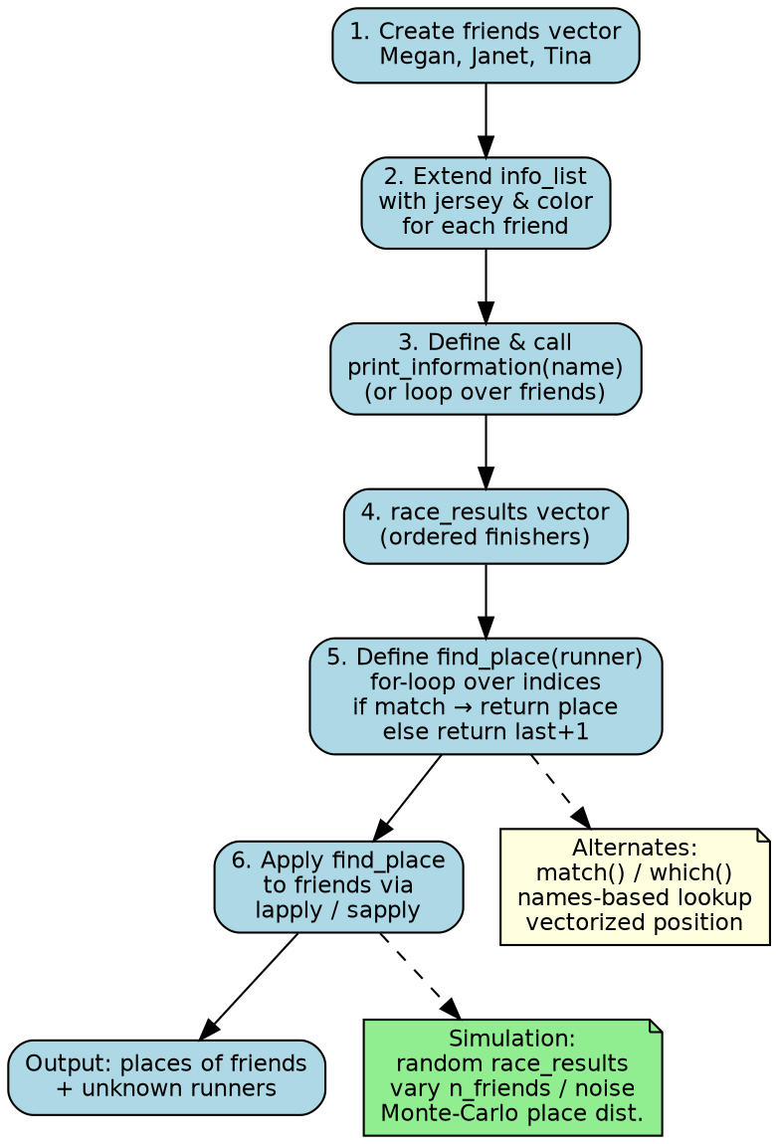
Key Takeaways
• Named lists + double-bracket assignment are the natural way to store heterogeneous per-person attributes.
• A simple for-loop with early return is pedagogically clear; match()/which() are the idiomatic, vectorized replacements.
• lapply keeps structure (list); sapply simplifies to an atomic vector when every element is a scalar—prefer sapply for numeric places.
• Returning length(v)+1 for “not found” keeps the result numeric and comparable, avoiding the special case of 0.
• Audience adaptation: show the loop version first to learners; show match() side-by-side for analysts; give executives only the final places table.
Files: Practice_Skeleton.ipynb • Solution.ipynb • Cheatsheet.docx • flowchart.png • Extended_Project.zip

